LAB NO: 2

LAB AIM: To study and apply Data Preprocessing techniques on given dataset. Prepare USA Housing dataset for training with machine learning algorithm using Linear Regression by applying suitable data preprocessing techniques.

DATASET AND RESOURCES : USA Housing Dataset and Python/Jupyter Notebook

DATE OF PERFORMANCE: 24 -07 -2026

GITHUB REPO LINK :
https://github.com/Prabhkirat-Singh-Marwah/ML-PRACTICALS/tree/main/Practical-02

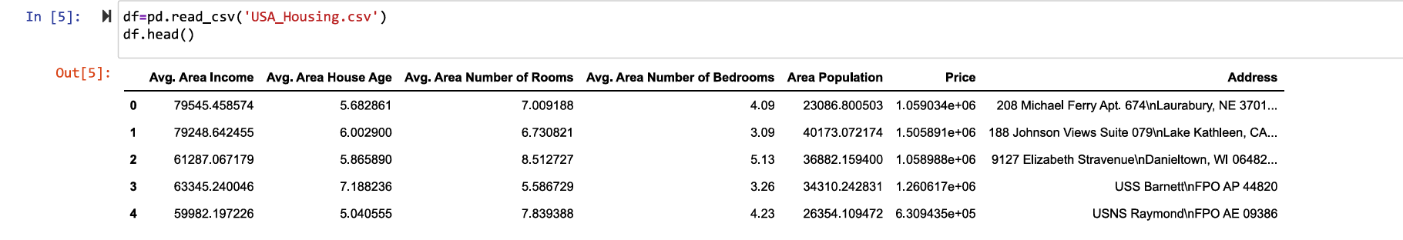
The df.head() command prints the first 5 rows of the dataset.

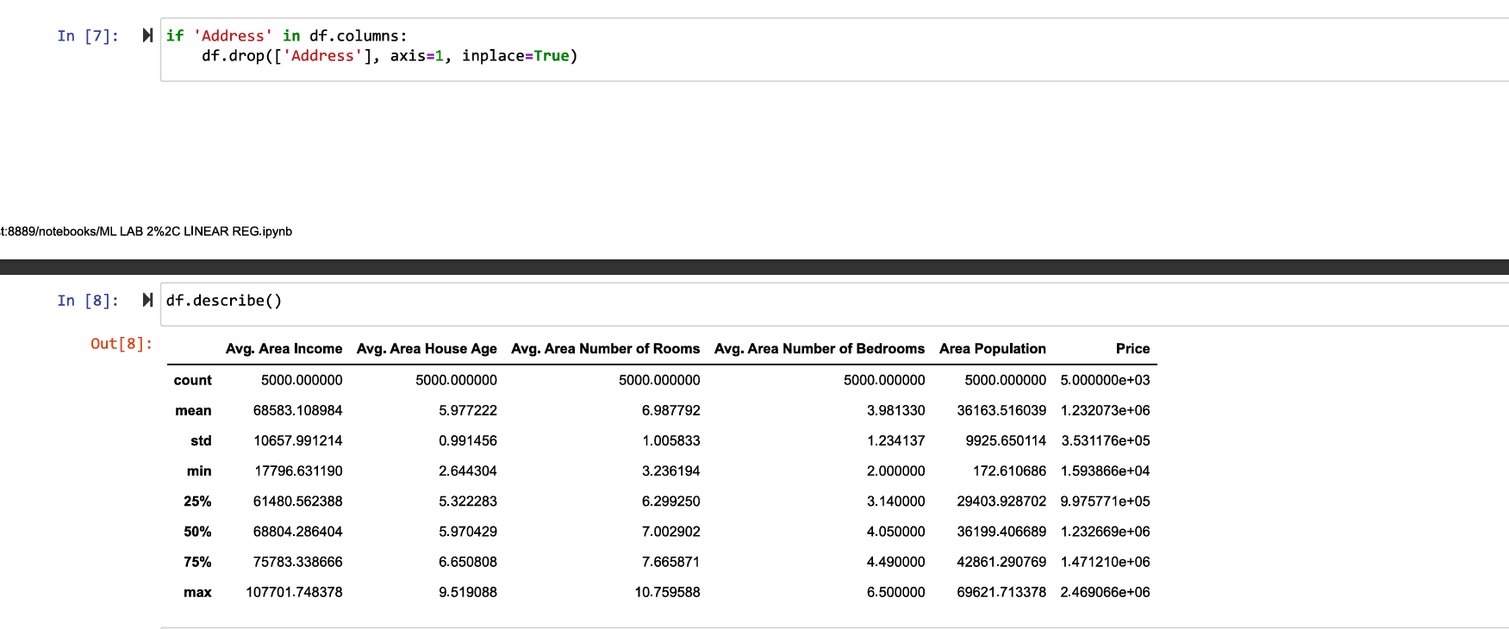
This commands deletes the column “Address” if it exist in the dataset and makes changes in original dataset directly, it doesn’t makes a copy and make direct changes in original dataset.

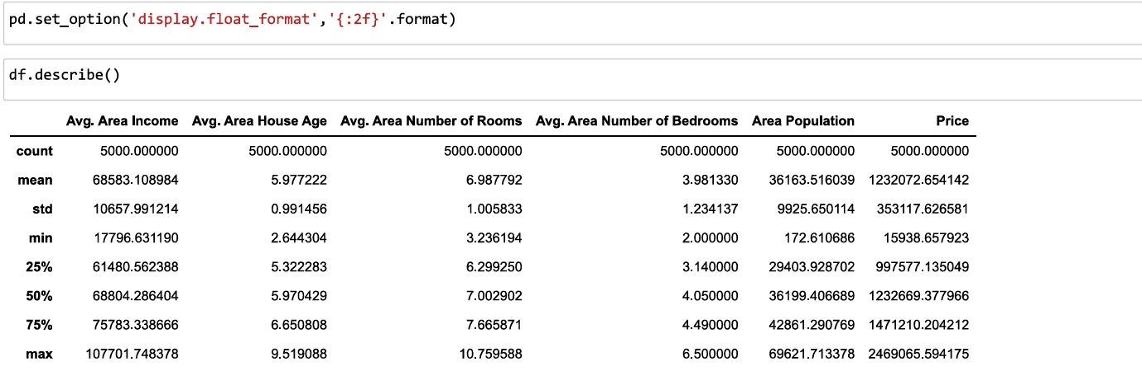
This command changes the format of representation of our numeric values .
df.describe() shows only the statistical summary values like mean, std deviation and some other mathematical values only

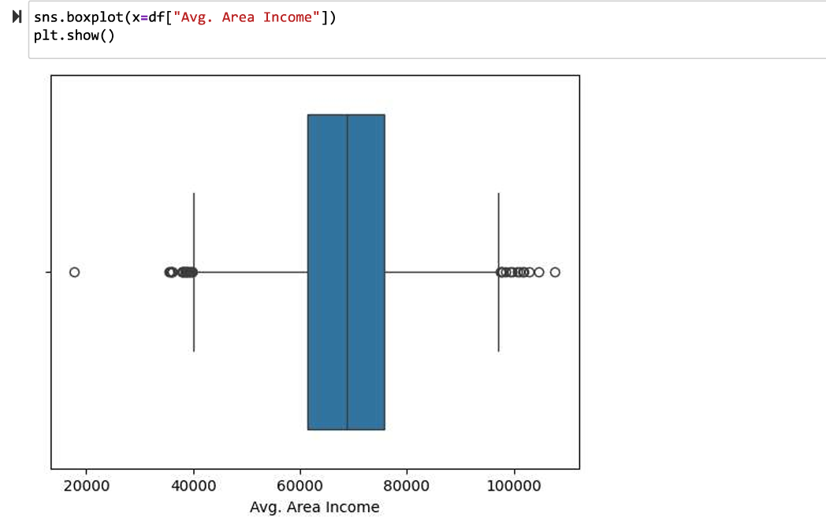this command prints the boxplot of avg area income to find the outliers values in our dataset. The values far away are the outlier values .

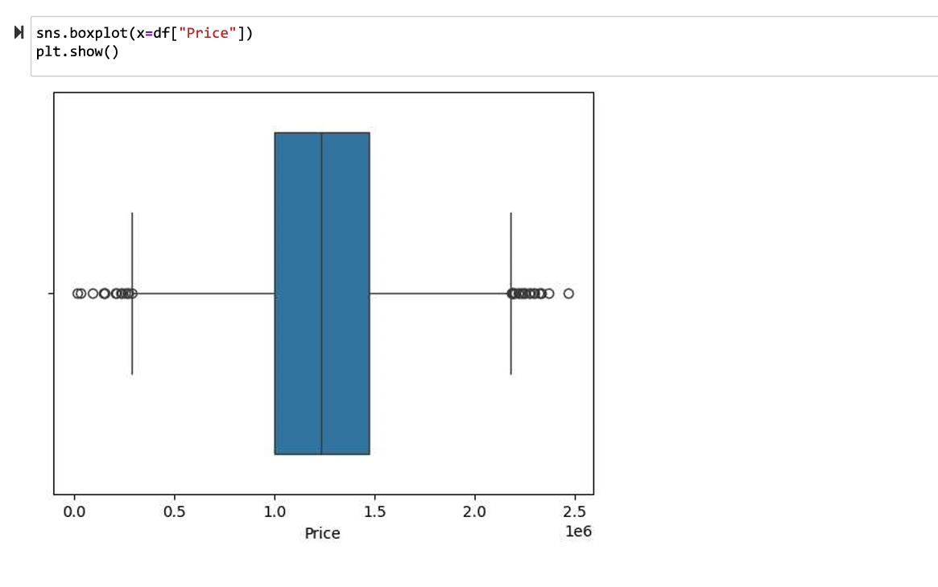this command prints the boxplot of price and helps to identify the outlier values of our dataset.

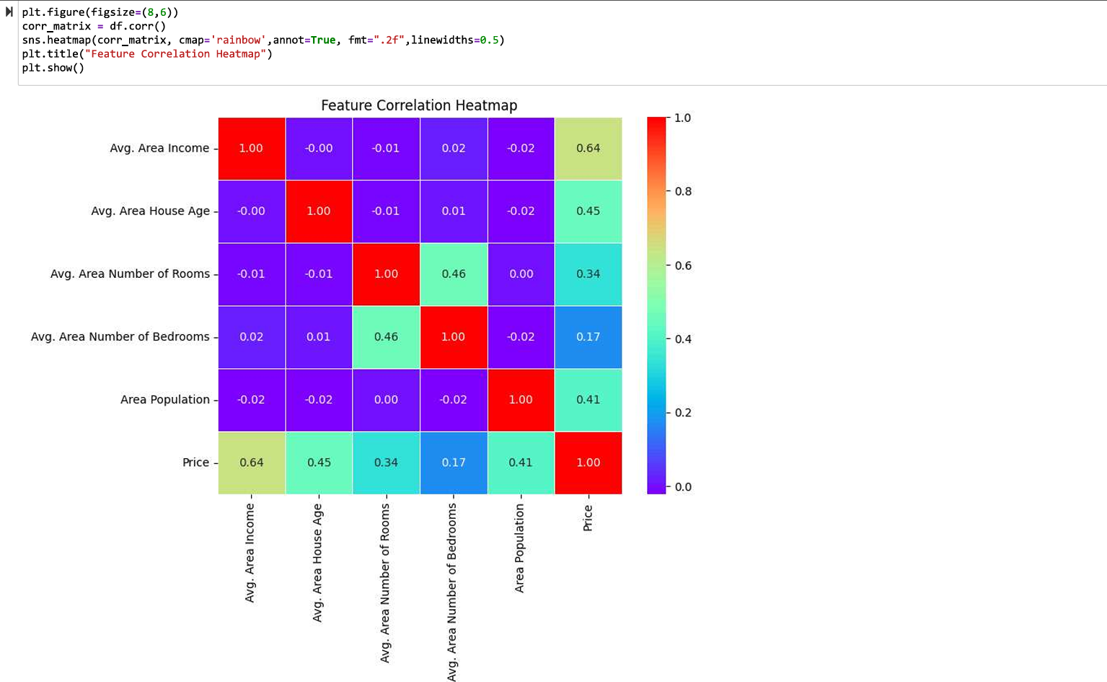This command prints the heatmap of the correlation between different variables of our dataset.
This heatmap shows how strongly each feature is related to others using correlation values from -1 to 1.
Values closer to 1 mean strong positive relationship, closer to 0 means weak or no relationship.
Price is most related to Avg. Area Income (0.64), so it’s the most important feature.
Bedrooms has very low correlation (0.17), so it is the least useful feature.

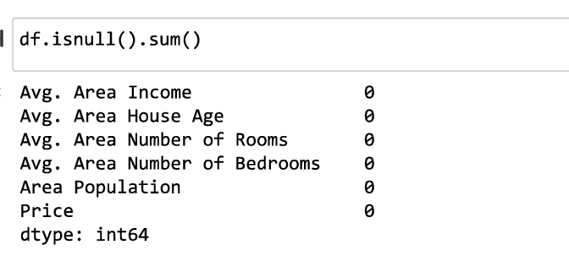
This command checks if there is any null value in any column ,since here all values are 0 means we have properly preprocessed our dataset with no null values in it .

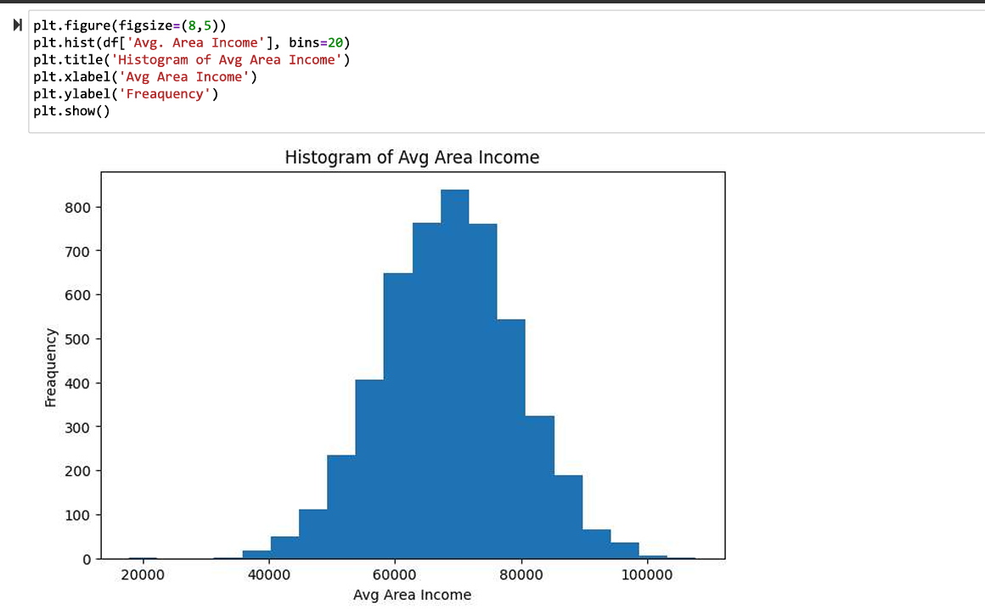
The histogram shows the data is approximately normal.
Most income values are concentrated around 60k–75k, which is the central range.
There are a few values at the extremes, showing the presence of minor outliers.

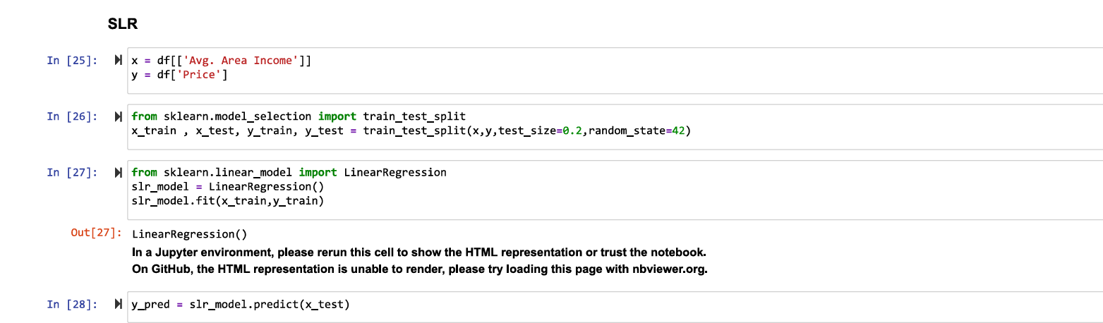

We selected Avg. Area Income as the input and Price as the output.
the dataset was split into training data (80%) and testing data (20%).
A linear regression model was created and trained using the training data.
The model learned the relationship between income and house price.
Then, predictions were made on the test data using the trained model.

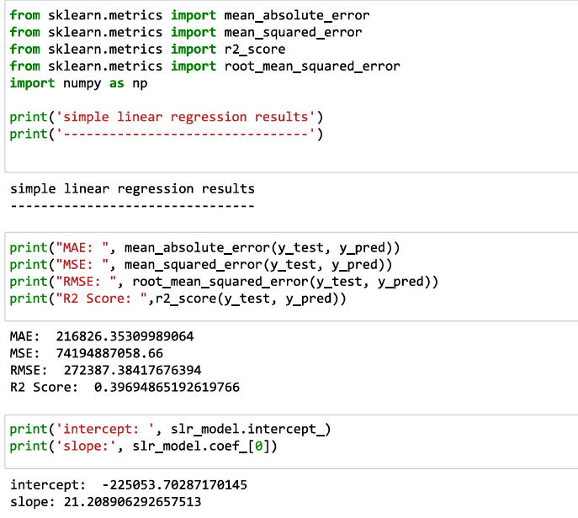these are basic command where we import the formulas for mae mse r2 score and rms from the sklearn library to get the calculated outputs for out dataset

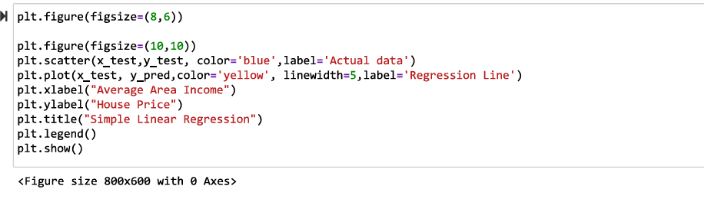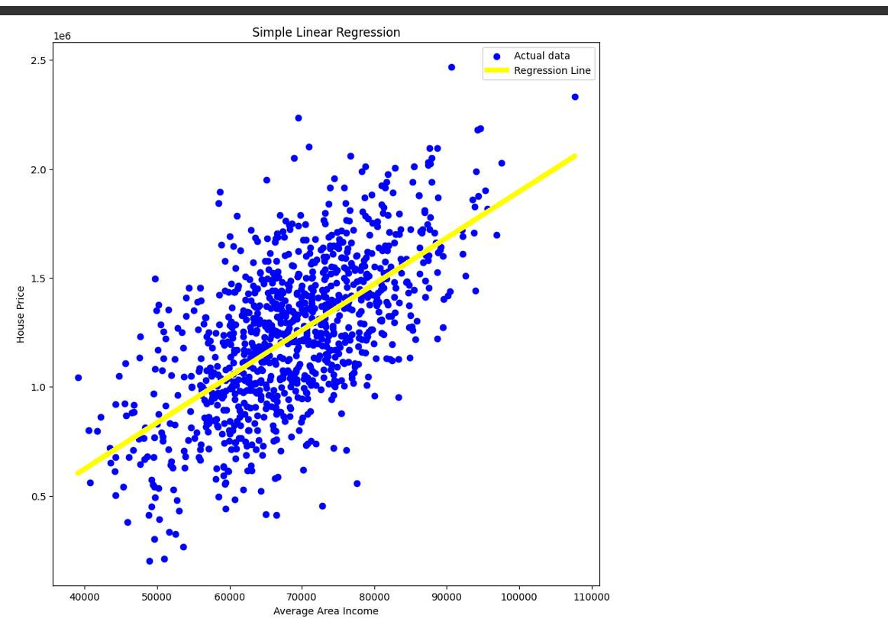
The blue dots show the actual data points between income and house price.
The yellow line is the best fit line predicted by the model.
As income increases, house price also increases, showing a positive relationship.
The points are somewhat close to the line, which means the model is working properly.

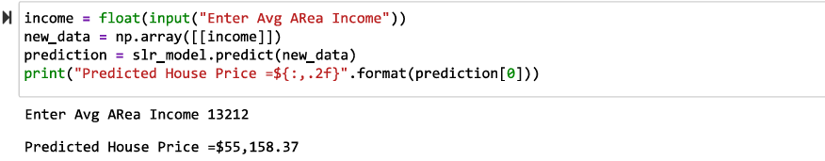This command takes input form user about his avg income .
The model then converts the value into its format of understanding
The model then predicts the price for this house based on the data is has been trained earlier .
The output is printed and displayed on the screen .

VIVA QUESTIONS
- What is Linear Regression?
Linear regression is a method used to find the relationship between input and output variables.
It fits a straight line to predict values.

- Why did we remove the Address column?
Address is text data and cannot be used directly in a regression model.
It also does not provide useful numerical information for prediction.

- What does df.describe() do?
It gives statistical summary like mean, min, max, etc.
It helps in understanding the distribution of data.

- What do axis=0 and axis=1 mean?
axis=0 refers to rows, and axis=1 refers to columns.
Operations are applied accordingly based on the axis.

- What does kde=True do in a histogram?
It adds a smooth curve over the histogram.
This helps in understanding the overall distribution clearly.

